**JOB DESCRIPTION**

**Position Title:** Nurse Practitioner

**Program/Location:** Community Health Care/Renfrew County

**Reports to:** Director, Renfrew County

**Role Summary**

The Primary Care Nurse Practitioner (NP) functions as a member of the Primary Care Team in the provision of primary health care services offered at ConnectWell Community Health. Primary health care services are provided at ConnectWell and in the community with an emphasis on health promotion, client education and self-management. The RN (EC) must be aware of, understand, and adhere to the Standards of Practice set out by the College of Nurses of Ontario.

**POSITION REQUIREMENTS**

1. **Education**

* Bachelor of Nursing
* Nurse Practitioner – Primary Health Care Certificate
* Current and unrestricted registration with the College of Nurses of Ontario as an RN[EC]

1. **Professional Experience**

* Three to five years of nursing experience in an expanded nurse role preferably working in a community setting.

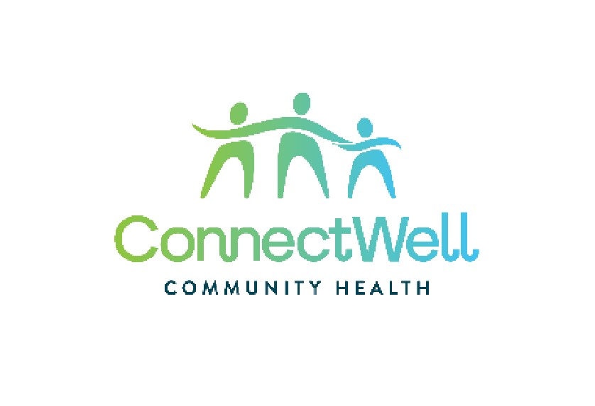

* Excellent health assessment and clinical skills.

1. **Key Competencies**

* Demonstrated ability to work effectively as a member of an inter-disciplinary team.
* Experience in the development and delivery of health education and health promotion programs.
* Excellent communication skills, both oral and written.
* Excellent organizational and interpersonal skills.
* Experience and understanding of rural communities and rural health needs.

1. **Work Conditions**

* Clinical work environment
* Use of computer
* Close contact with clients
* The ability to move around freely (standing, bending, sitting, etc)

**POSITION RESPONSIBILITIES**

* Provides ongoing, comprehensive clinical services to clients either at ConnectWell or in the community, taking into account the environmental, social, psychological and medical factors which influence health.
* Performs clinical duties by seeing and assessing clients for routine health and illness care and prescribing treatment as required. Services are provided at ConnectWell and in the client’s home, if required.
* Provides urgent/emergent care when required.
* Encourages clients and their families to take responsibility for their own health by involving them in risk factor and health problem identification, goal setting, and the choice of interventions for disease treatment and prevention and health promotion.
* Ensures appropriate, comprehensive treatment is delivered by maintaining complete and accurate medical records for all clients, participating in chart reviews, discussion of complex cases, and referring clients to other health professionals and programs both within ConnectWell and in the community.
* Promotes an inter-disciplinary approach to the provision of care.
* Providing appropriate support and consultation to other staff within ConnectWell and participates in staff and team activities as required.
* Facilitates the administration of the Centre by identifying areas where the development of protocols and procedures is needed to ensure high quality services or to promote effective team functioning.
* Assists with the overall planning, development and evaluation of health services by identifying health needs in the community and working with other team members to develop methods for program evaluation.
* Plans and participates in outreach activities related to primary health care.
* Initiates and maintains functional relationships with relevant community professionals, agencies and services.
* Provides health education, health promotion, disease prevention and health advocacy services to individuals and to groups as resources permit, in response to specific requests or identified strategic needs.
* Performs other related duties as required

**Standard ConnectWell Employee Responsibilities**

As an employee of ConnectWell, this position is responsible for the following:

**Administrative**

* Preserves confidentiality of all client and employee information and seeks to minimize risk while working with data
* Submits records of time worked and time off in a timely manner
* Maintains and develops professional competence, and where applicable, a professional license to practice, through appropriate continuing education methods (e.g. peer interaction, literature review, conferences, courses, staff development leave, etc.)
* Complies and adheres to all applicable ConnectWell policies and procedures

**Organizational Responsibilities**

* Respects and values the diversity of the community and individuals
* Supports the organization’s student placement programs
* Contributes to the organization’s work by participation in activities that seek to strengthen collaborative and interdisciplinary teamwork, such as committees and working groups, strategic planning and accreditation
* Contributes to the organization’s practices of hiring, orienting and training of employees
* Participates actively in team meetings
* Consults with and provides support to team members and other ConnectWell employees regarding professional issues
* Participates in the development of policies and procedures by providing feedback in the organization’s policy development process
* Works in a manner that incorporates health promotion and recognizes the determinants of health
* Participates in team and individual professional development opportunities

**Occupational Health & Safety**

This position must also work within the scope of all legislative and ConnectWell Health and Safety policies. In this capacity, the employee:

* Works in a manner that promotes a safe, secure environment, and is compliant with the Duties of Workers under the Ontario Occupational Health & Safety Act (Section 28)
* Must read and follow all ConnectWell Occupational Health & Safety policies
* Works safely in consideration of the following job hazards: noise, workplace violence
* Participates in Occupational health & Safety training as required:
* AODA
* WHMIS
* Employee Safety Training
* Other (as required)

I ______________________ have read this job description and understand and accept the responsibilities outlined within. I have also been given a copy of this job description.

____________________________ ___________________________

Employee Signature Date

_____________________________ ___________________________

Supervisor Signature Date